Anthony Long

Affective Computing

CAP 5627

Project 1 Write-up

1. My best metrics were EDA and fusion of metrics. EDA is a measure of the sympathetic nervous system activity. It changes during various mental stresses which can occur in responses to pain or stress, which I suspect is why it was highest, and combining metrics helps the classifier have better precision since it has multiple factors to train and test on.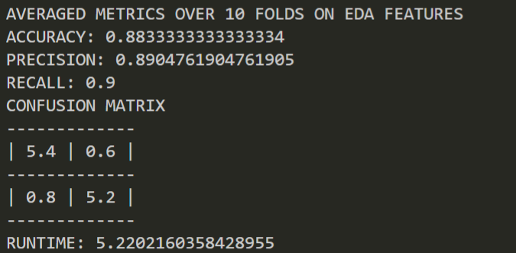

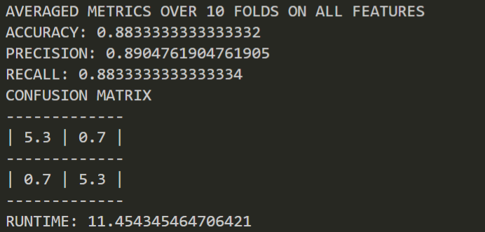

1. As stated, my fusion metrics were on par with the best accuracy scores for the project. I believe this occurred because when doing fusion of metrics there are more metrics to cross reference for training the classifier. All of the metrics also have a correlation with pain, so the classifier was able to detect trends and changes, and build its classifier based around the fusion of those metrics better than most individual metrics.
2. Seen in the graph, it is evident that there is high variability in diastolic and systolic blood pressures, which is likely due to the fact that blood pressure tends to spike and drop erratically when people experience pain.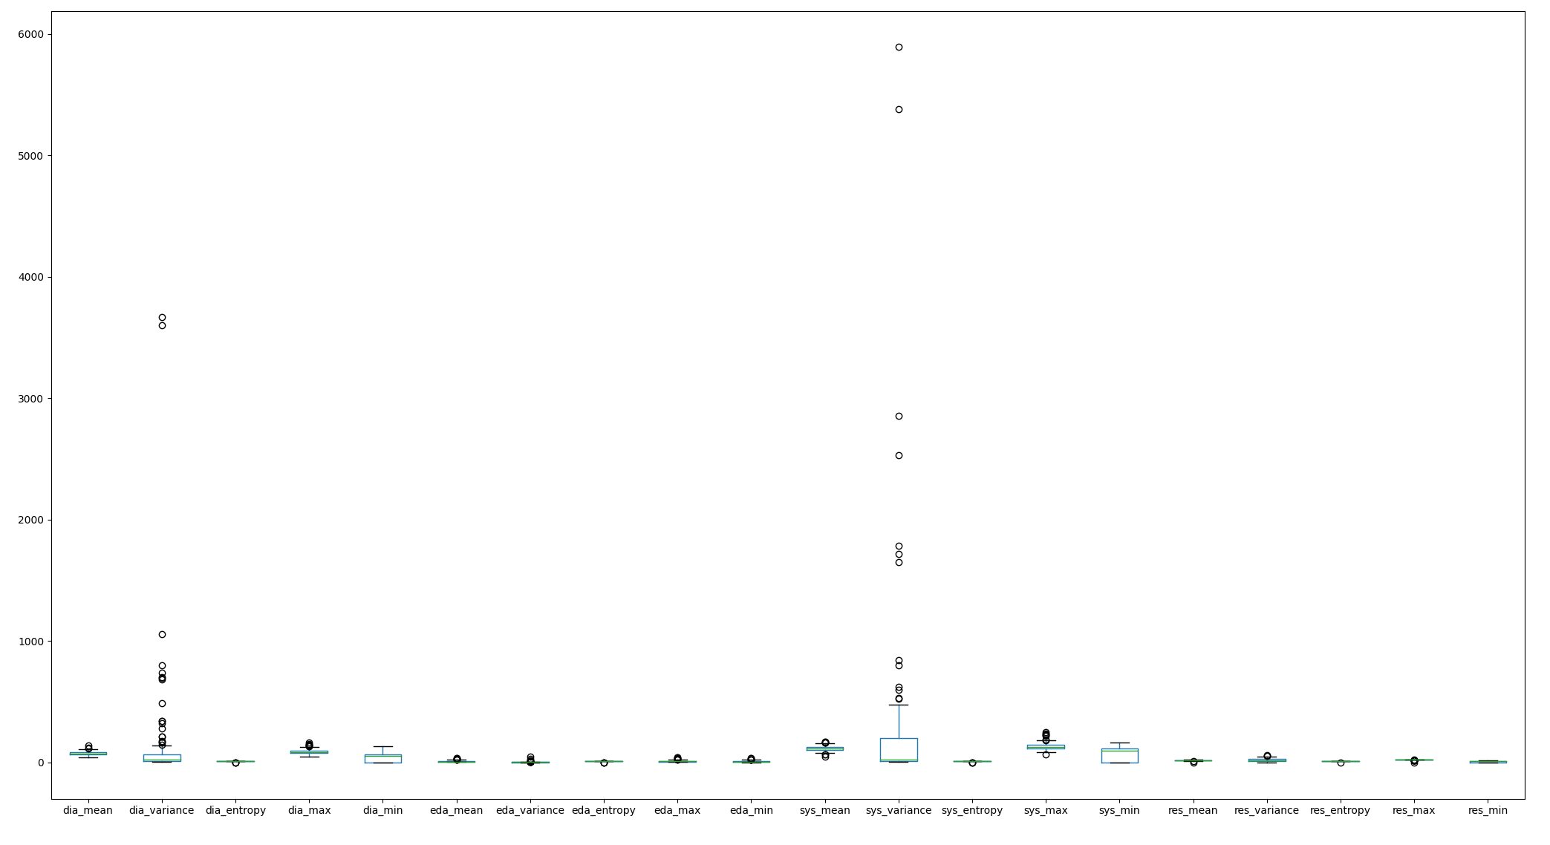

(left to right, there is dia_mean, dia_var,dia_ent, dia_max, dia_min, eda_mean, eda_var,eda_ent, eda_max, eda_min, sys_mean, sys _var, sys _ent, sys _max, sys _min, res_mean, res _var, res _ent, res _max, and res _min.)

1. Again, from the graph, we can see that diastolic and systolic blood pressures tend to fluctuate the most. In particular, systolic blood pressure has a range of 120+, indicating a very strong correlation with pain. Blood pressure in general is related to stress and pain, and this is logical since when people are in stress or pain, their body has physiological reactions, and their heart rate increases, causing the heart to pump more blood through the body which would cause an increase in blood pressure. This is reflected appropriately in the graph with the fluctuation in both diastolic and systolic blood pressure, while respiration and EDA are more consistent and predictable (seemingly).

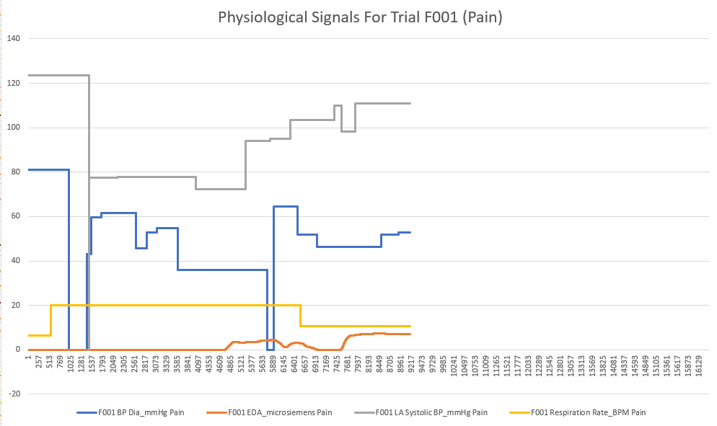

1. It is very likely that physiological signals are correlated with facial movement when experiencing pain, stress, and other negative emotions. Typically, people become defensive and their body tenses up in a natural evolutionary reaction to prepare for potential danger that could have caused pain. Facial expression and physiological signals are often studied together, and [1] found that there is a relationship between blood pressure and muscle contraction in certain situations.

References

Abdat, F., et al. “Bimodal System for Emotion Recognition from Facial Expressions and Physiological Signals Using Feature-Level Fusion.” 2011 UKSim *5th European Symposium on Computer Modeling and Simulation*, 2011, doi:10.1109/ems.2011.21.